CHEM 103: Honors Integrated General Chemistry
Section 084, 085, 086, 087 (ISEL 410)

Table of Contents
*click on the page number to automatically get to the page you want*
Instructional Team Information 2
Course Overview 2
Required Materials 2
UD General Education Goals 3
Example Course Learning Outcomes 3
Course Management & Class Time 4
Grading 4
i>Clicker2 Class Participation 5
Sapling Online Assignments 5
Sapling Online Quizzes 5
SmartWork 5
Discussion/Writing 6
Workshop 6
Lab 6
Exams 6
Assigned End-of-Chapter Problems 6
Exam Policies 7
Grading Disputes & Minimum Req. for Passing CHEM 103: 7
A Note On Academic Honesty: 7
Doing Well in This Course 8
Course Communication & Emails 9
Expectations about Classroom Behavior 9
Email Communication 9
Other Resources: 10

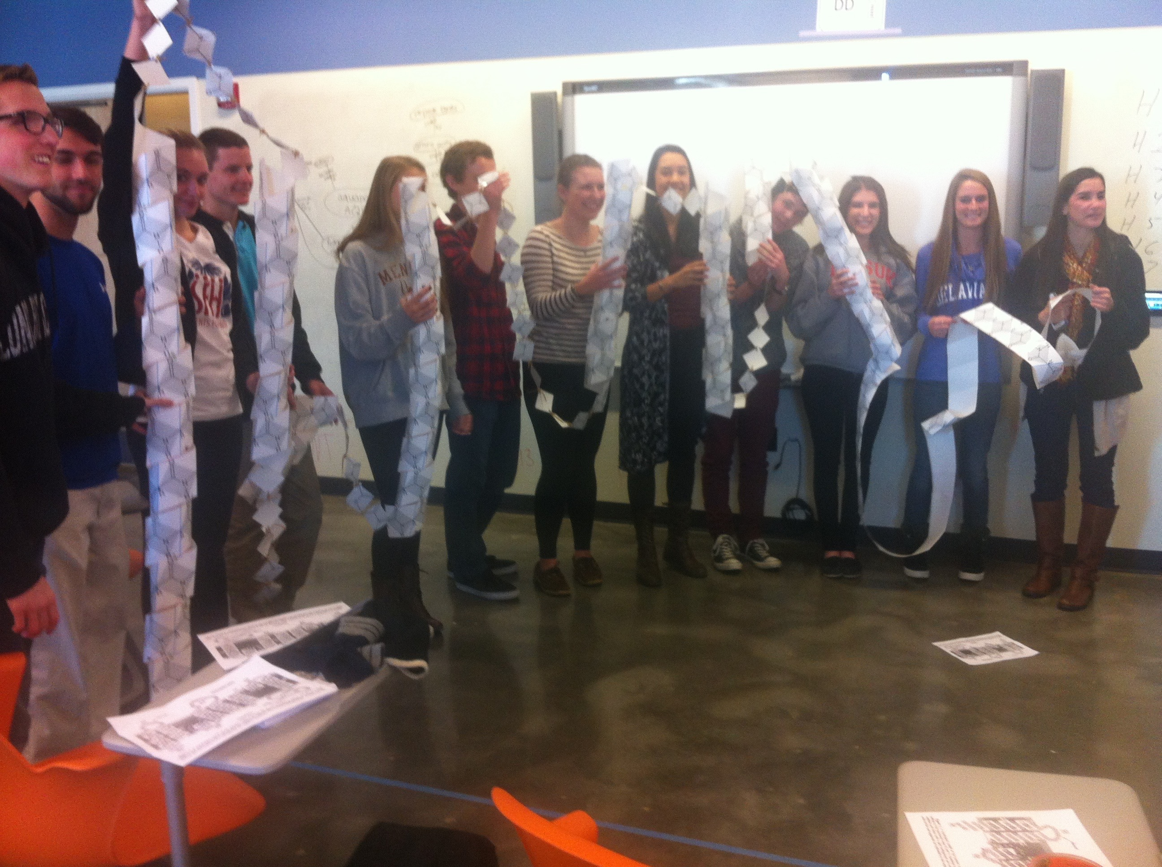
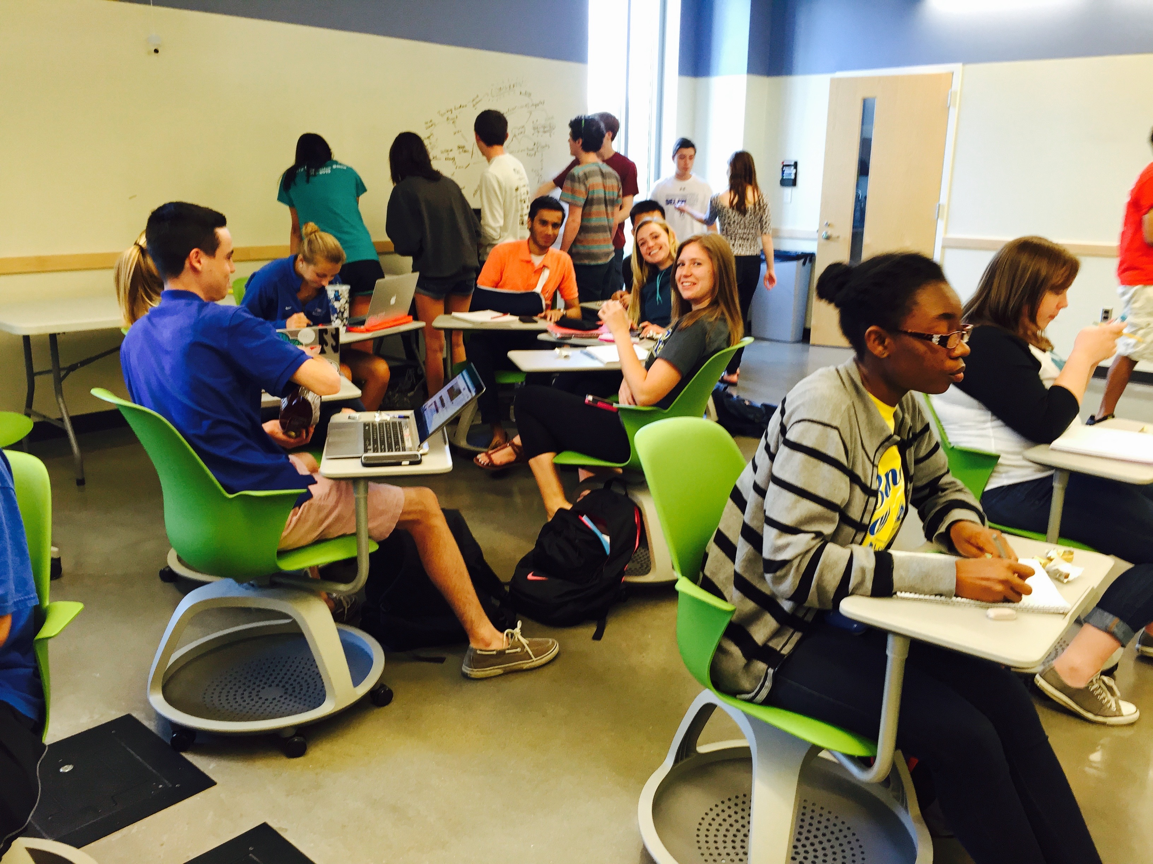
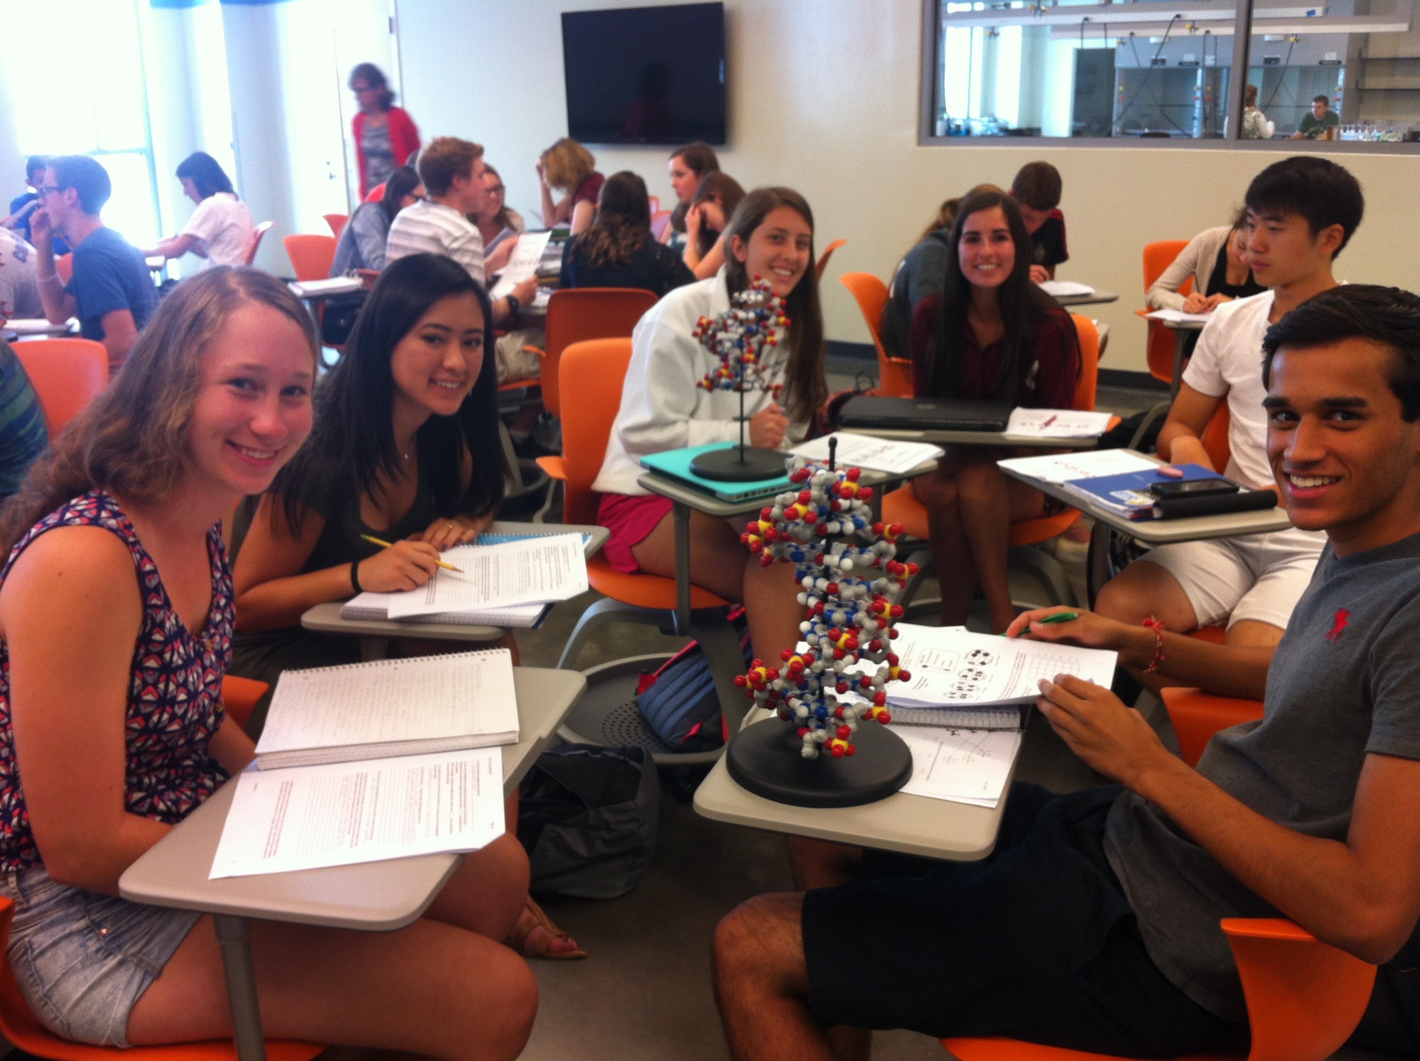
Social, Collaborative, and Dynamic Learning Experiences
Interdisciplinary Science and Engineering Laboratory

Instructional Team Information
Preceptors:
Trevor Daly, Ph.D. Breonna Martin, M.Sc.
Office: ISEL402C ISEL402C
Email: tdaly@udel.edu breonna@udel.edu

Instructor: Jacqueline L. Fajardo, Ph.D.
Office: 169 Brown Lab & ISEL 402 G
Email: jfajardo@udel.edu
Office Hours: See Canvas for weekly hours
and by appointment

Course Overview
Chemistry is a very diverse field and, at its most basic level provides the theoretical foundation on which we begin to understand the physical world that surrounds us. Chemistry is a science and thus uses systematic processes to observe, describe, explain, predict, and model both physical and chemical phenomena. It stands to reason then that as a learner of chemistry, you will also become skilled in each of these actions. To become skilled in applying the principles of this field to your more specialized interests, you must first learn how to speak the language of chemistry. This course will provide you with the tools you need to speak chemistry while providing you with an overview of relevant areas of interest in the context of this beloved discipline. Biological, medical, environmental, and societal applications will be embedded throughout your course. My commitment to you is that our journey into the sub-microscopic world of electrons, atoms, and molecules will be challenging yet rewarding. Welcome to your integrated honors course experience.

Required Materials
- Bundle of online homework, practice homework platform, and textbook (see Table 1)
  - Online access cards
    - Sapling (online homework)
    - SmartWork (practice resource – free from publisher with book purchase)
  - Classroom Text: Chemistry: The Science in Context by Gilbert, T., Kirss, R., Foster, N., & Davies, G. book. 4th ed.

- i>Clicker2: You will need the second-generation iClicker device to earn credit as we utilize the numeric input feature that is not possible with the first generation clicker.

- Safety Goggles (not glasses). Must be ANSI compliant.

Table 1: Homework and Book options. You will need to purchase ONE of the options (ISBN numbers) in this table. Please choose the package that best suits your needs.
Access Cards Sapling Homework & SmartWork | Gilbert Chemistry text | 1 semester ISBN | 2 semester ISBN
Sapling & SmartWork Access Cards | eBook & SmartWork & ChemConnections | 9780393571684 | 9780393571691
Sapling & SmartWork Access Cards | Loose-leaf print book & eBook & SmartWork + ChemConnections | 9780393571707 | 9780393571639
Sapling & SmartWork Access Cards | Hardcover print book & eBook & SmartWork + ChemConnections | 9780393571646 | 9780393571653
Sapling & SmartWork Access Cards | Paperback print book & eBook & SmartWork & ChemConnections | 9780393571660 | 9780393571677

UD General Education Goals
How does this course fit in the bigger picture of your education? This course was designed with consideration of the fundamental chemical principles that you will need to be successful in your scientific career. I have made an effort to include biological relevance to core chemical principles within the framework established by UD. General education at UD prepares students who are able to:

- Read critically, analyze arguments and information, and engage in constructive ideation.
- Communicate effectively in writing, orally, and through creative expression.
- Work collaboratively and independently within and across a variety of cultural contexts and a spectrum of differences.
- Critically evaluate the ethical implications of what they say and do.
- Reason quantitatively, computationally, and scientifically.

Example Course Learning Outcomes
Upon successful completion of this course, you should be able to apply knowledge gained from all readings, assignments, in-class exercises, workshop, studio and laboratory activities to be able to:
- Utilize a problem-solving framework (COAST) to make decisions.
- Design a method and utilize data to solve a real-world problem.
- Determine what can be inferred from a dataset and the conclusions that may be supported.
- Present, write, critique, discuss, and tutor your peers in the language of chemistry.
- Track atoms during chemical and physical changes making sure to conserve mass.
- Explain observable macroscopic properties through sub-microscopic principles.
- Infer elemental properties using a subatomic view of the atom.
- Predict the strength of interactions between two atoms (in a compound) based on the properties of the elements involved.
- Relate reactivity of a set of atoms (e.g. functional groups) to the identities and arrangements of the atoms within a compound.
- Predict nature and strength of interactions between compounds, described by intermolecular forces.
- Account for energy conversion & conservation between chemical, light, thermal, and kinetic forms.
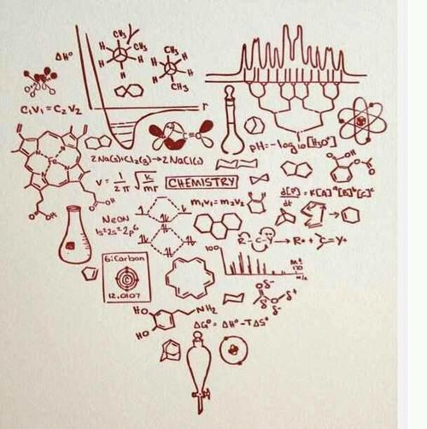
https://www.pinterest.com/pin/381750505884114250/

Course Management & Class Time

Course and lab materials will be managed using Canvas. Through this learning management system (LMS), you will be able to read course announcements, download lecture handouts, access links to resources, read and post onto the discussion forums, and review your grades. It is your responsibility to check the LMS often so you are up-to-date on readings, assignments, and other course- and lab-related material.

It is my goal to create an interactive atmosphere during this class so I do expect that students be actively engaged, interacting with peers and responding to queries from the teaching team. During class, I will clarify and elaborate on the readings, introduce material not covered in the readings, support class discussions, and incorporate activities and demonstrations. I strongly recommend that you read assigned material prior to attending class. Be sure to check the Resources page on Canvas for supplemental course materials. Don’t be afraid to question any information I am trying to convey. Chemistry, as any science, has its own set of limitations and assumptions. I hope that together we can explore these realms of uncertainty.

Grading

You will have the opportunity to earn up to 1000 points across the entire course as distributed via a straightforward point system. To calculate your grade percentage, simply sum your total earned points and divide by the total possible points. Please note that your final course grade will NOT be rounded up. The percentage you earn needs to cross the bottom threshold of each of the letter grades in the grading scale below (e.g., a 89.98% earns you an A-).

Course Component | Weighted Point Value | Percentage of Total Points
i>Clicker2 in-class quizzes | 50 points | 5.00 %
Sapling Online Assignments | 60 points | 6.00 %
Sapling Quizzes | 40 points | 4.00 %
Discussion / Writing | 50 points | 5.00 %
Workshop | 70 points | 7.00 %
Lab | 250 points | 25.00 %
Exams (including final) | 480 points | 48.00%

A- = 88.00-89.99% |  | A = 90.00-100%
B- = 75.00-77.99% | B = 78.00-83.99% |  | B+ = 84.00-87.99%
C- = 59.00-62.99% | C = 63.00-71.99% |  | C+ = 72.00-74.99%
D- = 50.00-52.99% | D = 53.00-55.99% |  | D+ = 56.00-58.99%
 | F < 50.00%
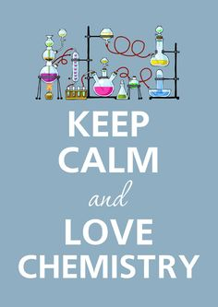
https://www.pinterest.com/Samaadkins/chemistry/
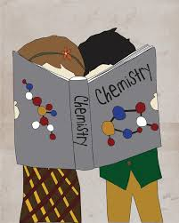

Course Requirements – Details

i>Clicker2 Class Participation
You must register your iClicker2 through Canvas immediately. To register your device, go to the lecture Canvas page for this course, click on the iClicker tab on the left side of the page, and enter the ID number from the back of your clicker in the registration box. After submitting, scroll down and make sure that you see your number has been registered on that same page. Bring your iClicker2 to EVERY class period.

These in-class iClicker questions are meant to support and enhance your understanding of the course material and a good way for both you and me to gauge your level of understanding throughout the class.

You must answer at least one the question presented on any given day in order to receive credit for participation (worth 1 point per day). In terms of credit, it will not matter if you get the questions incorrect – points are awarded just for participation. Students occasionally forget their clicker or miss class for a variety of reasons (excused or unexcused), hence you only need to achieve 90% of the total points available to earn full credit on this component of the course. Those few days of forgetfulness or illness will have little to no impact on the overall grade you can earn. There will be no chances to make-up missed iClicker questions. You may not hand in a scrap piece of paper with your responses if you forget your clicker! It is important that you participate with only your own iClicker. If you participate in iClicker activities for someone else, this behavior is unacceptable and is considered academic dishonesty.

Sapling Online Assignments
To master foundational concepts in chemistry, you must dedicate a substantial amount of time reading and working through practice problems. Sapling online homework will provide you an opportunity to work through the problem solving process to supplement your problem solving from the class and text. Sapling assignments are designed to be a form of practice – regardless of the number of attempts you need to complete, you earn credit simply by completing the problem. You may find hints or tutorials helpful to complete a problem; feel free to use these resources as you wish. However, if you use the “Give Up” option, you will be able to see how to complete the problem, but will no longer be able to earn credit for that problem. You can use these problems as talking points during class discussions. Due to the extended length of time that assignments are open, there will be no chances to make-up Sapling assignments. If you anticipate being gone on the due date, complete the assignment before you leave. Late submissions will be marked down for every hour it is late (50% per day).

Sapling Online Quizzes
Your homework assignments are designed to give you ample time to master the material without a point penalty for your attempts. There will be a quiz on this material the day after each assignment is due. This Sapling quiz will reflect the problems that were on your assignment, but will be graded on the first attempt. The quiz will always occur on the day after the assignment is due and will be available from approximately 9:00 AM – 11:59 PM. You can start the quiz anytime it is open but beware that you have a limited amount of time to complete the quiz (typically anywhere from 15 to 30 minutes depending on the material). It is your responsibility to make sure that you have a stable internet connection (ideally hardwire through Ethernet cable) to minimize risk of disconnecting and losing time on the quiz. There will be no chances to make-up these quizzes.

SmartWork
You have access to an online homework platform tailored to your textbook. Assignments embedded herein are strictly optional but highly recommended for extra practice.

Discussion/Writing
Renowned poet William Stafford once wrote, “A Writer is not so much someone who has something to say as someone who has found a process that will bring about new things that he would not have thought of had he not started to say them” (Writing the Australian Crawl, 1977). We are very pleased to offer you extensive writing opportunities as a graded component of your first-year integrated experience. Your writing experiences will range from quick one-minute papers to longer formal, semi-formal, or informal pieces. Topics may be specifically content-driven and include or be more reflective in nature, perhaps with consideration of ongoing learning issues, knowledge gained, or skills mastered. Given the fluid nature of the course, your writing prompts and assignments will be provided propitiously.

Workshop
The ability to solve problems in varied and different contexts is a crucial skill in science. To hone this skill, you will convene weekly with a small group of your peers for a problem-solving session called Workshop, a two-hour highly active and engaging session led by an undergraduate peer facilitator. During Workshop, you may learn about concepts before they are introduced in class, and other times you may be refining your understanding of current or past course topics. You will receive credit for attending Workshop and being on task during the two-hours. Your workshop will be held on Wednesday evenings, 5:00 PM – 7:00 PM at a location TBD. You must bring the activity workbook, ChemConnections, to every workshop. You will incur a loss of points if you choose to attend workshop without this book.

Lab
Chemistry requires careful testing and data collection to explain observations. Systematically collected data may reveal trends that enhance your understanding of important chemical concepts. Refer to your lab syllabus for detailed information on labs. These labs will are designed to integrate equipment, concepts, and techniques from your chemistry and biology courses. We hope that you will sometimes be unable to distinguish “chemistry lab” from “biology lab”! Due to the high dependence on group work in lab, there is a VERY strict attendance policy that we urge you to take special note of.

Exams
There will be five exams (the 5th exam is given during finals week). The first four exams are semi-cumulative and the fifth is fully cumulative. Because of overarching theories and concepts that make up the study of chemistry, there will be questions that incorporate previously learned material. Not all of the material covered in class time will be in the textbook and we will not cover everything in the textbook during class time. However, any of the information presented in the assigned reading and end-of-chapter problems, class time, lab, workshop, and studio may be included in the exams.

“Never memorize something that you can look up.” – Albert Einstein I am not concerned about you memorizing equations. Rather, you must convey to me that you know how to use important equations. Hence, you are allowed to bring a 3” x 5” notecard to each exam with any hand written notes on it that you wish. Your name and ID# must be legible on the notecard, and turned in at the conclusion of the exam.

Assigned End-of-Chapter Problems
Although assigned end-of-chapter problems will not be graded, you are responsible for completing all assigned problems. Please keep up-to-date on these homework problems. Answers to boldface questions are in the back of the book. The solutions guide is available for checkout in the Chemistry Library, BRL 202. Fully worked out solutions to all end-of-chapter problems are in the Solutions Manual, which is available for checkout in two-hour blocks. More information on the Chemistry Library is here: http://www2.lib.udel.edu/branches/chem.htm.

Exam Policies
Excused Policy:
Acceptable reasons for missing an exam include serious illness, family emergencies, or military duty. Athletic participation and religious holidays not listed in University calendars are also acceptable reasons but note that for these reasons to be valid, advance written notification needs to be provided to me by the second week of the semester. If you do miss an exam for an acceptable reason, you will need to provide documentation (e.g., doctor’s note) and contact me immediately (within a day or two). If you have an acceptable reason, provide appropriate documentation, and notified me immediately, you may replace your missed exam score with the final exam score.

Unexcused Policy:
If you do not provide an acceptable reason for missing an exam, provide appropriate documentation, and notified me immediately, you may only replace one missed exam score with the final exam score.

Language Dictionary Use During Exams:
The University's policy states that a language barrier does not constitute a "special needs/learning disability" case, so students in this situation are not referred to the DSS Office. The CHEM103 policy for language dictionary use on exams will be to approve INSPECTED PAPER language dictionaries. ELECTRONIC language dictionaries will NOT be allowed at any time.

Special Accommodations:
If you have a documented disability that may need certain accommodations, please contact the Office of Disabilities Support Services (DSS) as soon as possible. I will do what I can to accommodate needs but certain requested accommodations (e.g., extended time exams at the DSS Center) require registration with the DSS. The DSS office is located at 119 Alison Hall, 240 Academy Street and their phone number is 302-831-4643.

Grading Disputes & Minimum Req. for Passing CHEM 103:
On occasion, a student may believe that they deserve a different grade on an assignment than they actually received or may believe that there is more than one right answer to a multiple-choice question. If you believe that a review of grades of warranted, you must meet with me within one week of receiving the grade/score. If you dispute a lab grade, you must meet with your TA to address the specific issue. After one week, your grade/score cannot be argued and is permanent. Be aware that if you request a grade correction, your entire exam is subject to re-grading. This may result in a lower overall grade.
Minimum Requirements For Passing Chem103 Are:
- Successful completion of the laboratory
- Completing the Final Exam
- Achieving an overall passing grade in the entire course

A Note On Academic Honesty:
All students at the University of Delaware are expected to be honest in their academic studies. As a pursuer of higher education, I ask that you strive to learn course content. Seek to demonstrate to yourself and your professors what you can do intellectually. Acts of plagiarism, cheating, and dishonesty simply cheapen your own educational experience and that of your peers. Let us set forth an honors-quality bar for integrity and authenticity. Note that cheating of any form will result in referral to the Dean of Students.

Please familiarize yourself with the Code of Conduct at the University of Delaware, which outlines the standards of student behavior, including guidelines regarding academic honesty: http://www.udel.edu/stuguide/13-14/code.html. Because this expectation to read the Code of Conduct is explicitly written in this syllabus and stated verbally during class time, pleading ignorance will not be a valid excuse. If you are caught committing an act of academic dishonesty, the incident will be reported to the Office of Student Conduct.

Doing Well in This Course
There are a few things that you can do to improve your learning experience in this course:
- Regular attendance
  - Sometimes, things happen so if you happen to miss a class period, you have a few options.
- Make friends with your classmates! If you ever have to miss a class because there’s an emergency, you can nicely ask a new friend for a copy of his or her notes.

- Read the assigned material associated with the class period before attending class
  - Suggested readings for the coming week will be linked on Canvas to a Google document.
  - Additionally, the publisher of our textbook has provided resources that are available through Canvas. Please see the interactive tools available there to get access to visual summaries, flashcards, chemtours, and additional questions and more.

- Active engagement during class time
  - Print out or download the lecture notes before class so that you can take notes on my discussion of the topic and participate in class discussions/activities.
  - Interact with your group members. Be proactive, productive, and proficient.
  - Push yourself to raise your hand to ask a question or contribute to discussion questions.

- Participate in the discussion forums and twitter (#UDChem)
  - Ask questions about course material sooner rather than later and have your peers or me help you! We will try to check this Discussion Board daily.
  - Share how you can apply chemistry to what you’re learning in other classes, what you are reading in the news, and your everyday life. Share on twitter!
  - Are we not covering a specific chemistry topic in which you are interested? Post a thought-provoking comment or question!

- Visit your Preceptor, TAs, or myself during office hours
  - You do not need to ask permission to come to office hours! Just come on by during the scheduled day and time! See Canvas for current office hour information.
  - We enjoy getting to know our students during these office hours! You are always welcome to discuss course material, broader questions about educational and career paths, or tips on studying. If you cannot make office hours and would like to schedule an appointment, please politely send an email request with your availability (e.g., Monday before class, Thursday after 11am).

- Watch this series of short videos on “How to Get the Most Out of Studying”
  - These videos address (with psychological research!!) the common issues that some students have reported as challenges to their success in this course – (1) misconceptions about learning, (2) levels of processing information, (3) developing effective studying strategies, (4) practicing effective studying, and (5) what steps to take when students earn a bad exam grade.

Course Communication & Emails
I will post announcements, course material, and other important information on Canvas so it is important that you regularly check your UDel email and the course website regularly.

Email is the best way to reach me. Please know that responding to emails promptly is a priority for me. However, in general, please allow approximately 48 hours for responses to your emails. If you do not receive a reply within these time frames, please feel free to send me another email as a reminder.

Expectations about Classroom Behavior
Please be courteous to your fellow classmates, your group mates, and your teaching team. I am taking this opportunity to express my expectations of you during lecture, laboratory, workshop, and outside of class on discussion boards or group work. If any student chooses to violate any of these expectations or engage in disrespectful behavior, your workshop leader, TA, Preceptor, lab staff, or myself may ask you to leave. Disruptive behavior impedes your learning and that of your classmates, thus will not be tolerated.

- Avoid coming in late or leaving early. Pack up your belongings only after the class time has ended.

- Refrain from talking during class time when others are speaking. Take a look at the learning studio you are sitting in – notice that even casual whispering will be loud and distracting.

- Be mindful of your use of technology in the class. There is evidence that multitasking on a laptop lowers students’ grades by 10% and lowers the grades of peers that see a multitasking screen by 17% (Sana, Weston, & Cepeda, 2013). That is more than one full grade! You may use technology in the classroom to look up material relevant to the class material, post questions on the discussion forums, or to take notes. Do NOT text or engage in any activity that is not relevant to this class.

- Turn off or silence your cell phones or other electronic devices before entering the classroom. There is evidence that the interruption of a ringing cell phone negatively affects note-taking efficacy and impairs test performance on the material that was interrupted (End, Worthman, Mathews, & Wetterau, 2010).

Email Communication
Because of convenience, email communication is generally very common between instructors and students. Thus, it is important to recognize the importance of email etiquette:
- Include a proper greeting.
  - A simple hello or a “Hi Professor Fajardo” is great! Learning to communicate professionally and with tact takes practice.

- Let me know which course section you are taking with me.
  - I teach multiple sections of this course so please include the class name and section number either in the subject line or within the body of the email. This will allow me to provide tailored responses to content specifically discussed during your section.

- Tell me who you are.
  - Consider the email like a traditional letter that you would write by hand and include a “signature” with your first and last name. I like to get to know my students and reply to your emails with proper greetings as well!

- Check the syllabus before you email me a question.
  - I try to be very thorough (as you can tell from the page count!!) when I create the syllabus and it will often answer most general questions about the course. The syllabus is detailed.
- Post onto the Canvas Discussion Forums.
  - I encourage students post their questions to the forums rather than sending me an email. In some cases, your fellow classmates may be able to help you out. In other cases, your classmates may have a similar question and everyone can benefit from a response to this question. Either your TA or I will regularly check this Discussion Board.

- Be professional.
  - Use complete words and sentences and check for errors in your email. Please do not use text-messaging abbreviations or send a series of emails as you think up questions. “Hey, when r u postin the study guide” is not appropriate. When you are composing an email, ask yourself if the tone professional and respectful. Is this a message you would send to your boss at a job?

- Multiple questions?
  - If you have several questions, or require a very detailed answer, it may be difficult to respond in an email, so please visit office hours or schedule an appointment.

Other Resources:
- Tutors (Private and Group) - For more info, see Mrs. Staib in BRL102 (831-2465)
- Tutoring is free and open to all UD students in ISEL 314. http://www.cas.udel.edu/isll/learning-community-center/Pages/default.aspx
- Academic Enrichment Center: http://ae.udel.edu/tutoring.html offers individual, drop-in, and group tutoring to all students. Drop-in and group tutoring is free of cost to all students.
- Academic Code of Conduct: http://www.udel.edu/stuguide/13-14/code.html
- Information on excused absences and procedures can be received from the University’s Undergraduate and Graduate Catalog
http://academiccatalog.udel.edu/Pub_ShowCatalogPage.aspx?CATKEY=CATKEY_471&ACYEAR=2013-2014&DSPL=Published

We are on Twitter!
WE have a Twitter account! If you would like to learn more about chemistry in the news, the UD Department of Chemistry, and about events and opportunities happening on campus and around the region, you might want to consider following @Jackie_Fajardo. Feel free to post articles that you think add to our understanding of chemistry in the context of the world around us by posting to #UDChem! To decide if a tweet is appropriate, ask yourself if you think others in the class could benefit by your tweet.

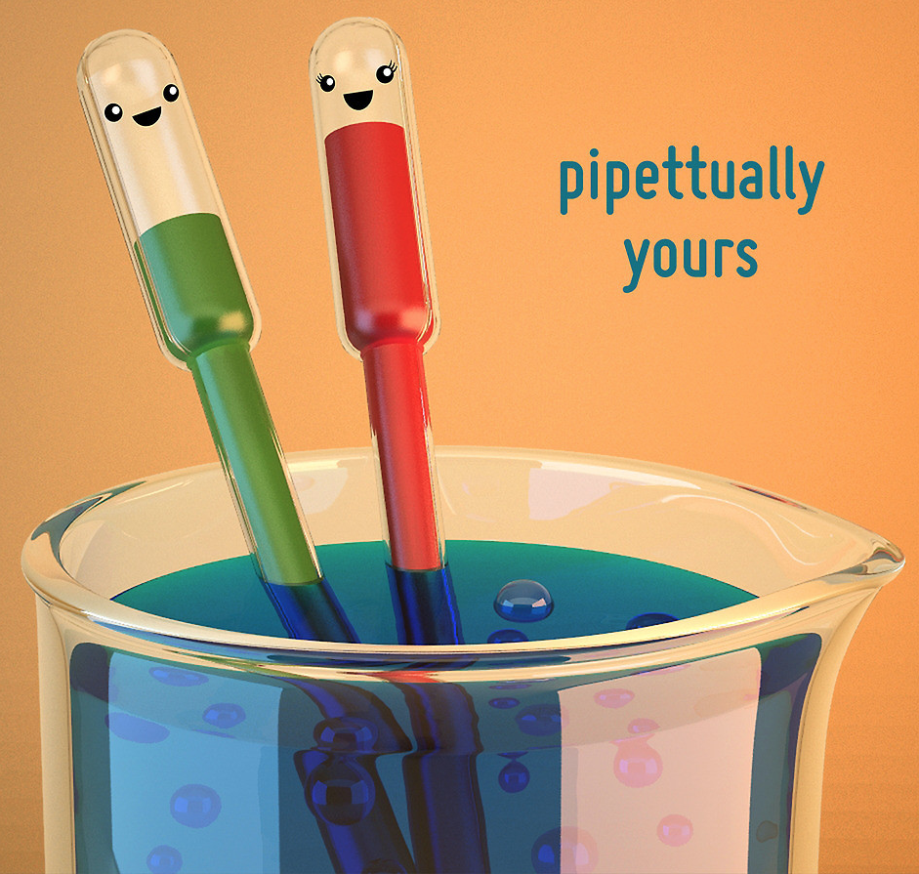
http://www.redbubble.com/people/chayground/works/10056772-pipettually-yours-cute-chemistry

*note: the online only options can also be purchased directly from Sapling through the Canvas “Assignment” portal. If you would like to buy or rent a copy of the book in addition to the digital options, you will need to do this at one of the campus bookstores.
Outcomes 1-4 are focused on solving real-world problems using general scientific practices. Outcomes 5-11 are focused on solving real-world problems using specific chemical knowledge.
aIf you are considering changing to a Listener status or Withdrawing from this class, you must make an appointment with your chemistry and biology professor immediately. These two courses are linked, and your decision to change status in either course has broad implications.

